**Name : Puna Poudel**

**Assignement: 5.2**

**Profesor: Chandra Bobba**

**Due Date: 02/09/2025**

**Value Stream Mapping: Optimizing the Daily Routine**

**Introduction**

Value stream mapping (VSM) is a practical method for analyzing and improving workflows by identifying inefficiencies and streamlining processes. This analysis focuses on a typical daily routine, mapping each step, evaluating lean metrics, and exploring opportunities for optimization.

**Value Stream Map (VSM) for a Whole Day Routine:**

The daily routine includes the following steps, each step is visually depicted in a flowchart to illustrate the sequence.

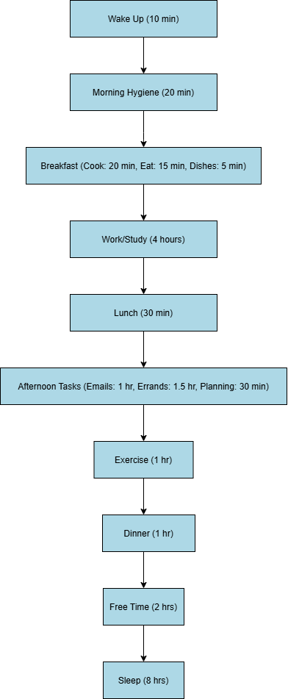

**Lean Metrics Analysis** The estimated time for each step is as follows:

* **Wake Up:** 10 minutes
* **Morning Hygiene:** 20 minutes
* **Breakfast (Cook - 30 min, Eat - 15 min, Dishes - 15 min):** 60 minutes
* **Work/Study:** 5 hours
* **Lunch:** 30 minutes
* **Afternoon Tasks (Emails - 1 hr, Errands - 1.5 hr, Planning - 30 min):** 3 hours
* **Exercise:** 1 hour
* **Dinner:** 40 minutes
* **Relax/Free Time:** 2 hours
* **Sleep:** 8 hours
* **Total Estimated Cycle Time:** 21 hours and 45 minutes

**Process Optimization Strategies**

**Eliminating Waste:**

* **Morning Hygiene:** Simplify the routine by preparing essentials like clothing the night before.
* **Breakfast and Dinner:** Utilize meal prep techniques to reduce cooking time.
* **Afternoon Tasks:** Batch related tasks like emails and planning to reduce switching times.

**Workflow Orchestration:**

* **Work/Study:** Implement short breaks using the Pomodoro technique to maintain focus and productivity.
* **Exercise:** Combine warm-ups and light cardio to optimize workout time.
* **Relax/Free Time:** Set clear boundaries to ensure this period remains restorative and not encroached upon by tasks.

**Conclusion**

By applying VSM to a daily routine, inefficiencies can be highlighted and resolved, enabling a more balanced and productive day. These optimizations not only save time but also enhance the quality of activities, fostering a healthier and more fulfilling lifestyle.